1. create Git profile(git username and email)

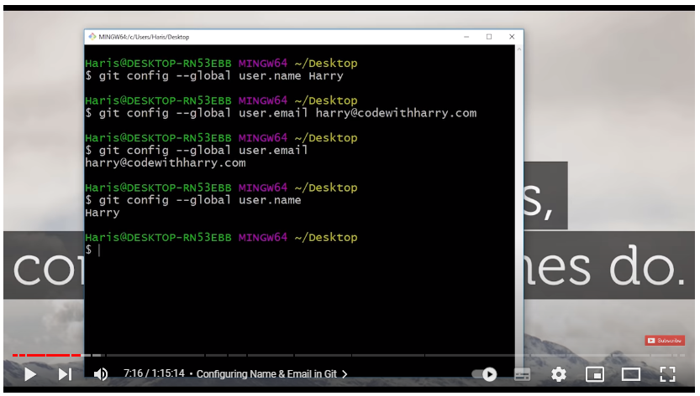

1. open visual studio for that sent command “$code .” and then we initialize the empty repository “$git init”

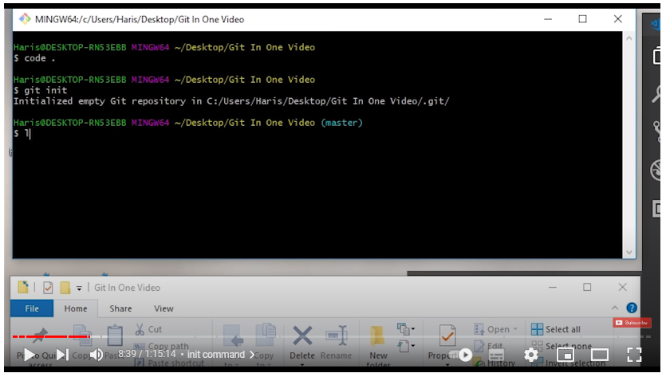

1. to check hidden hidden folder “$ls –lart”

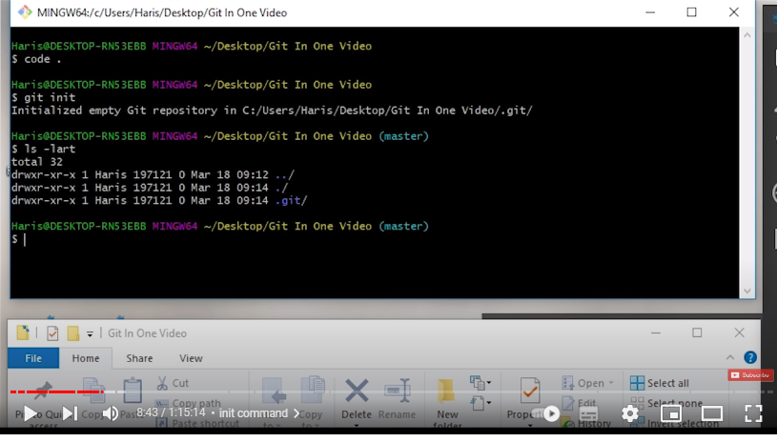

for git status check we use “$git status”

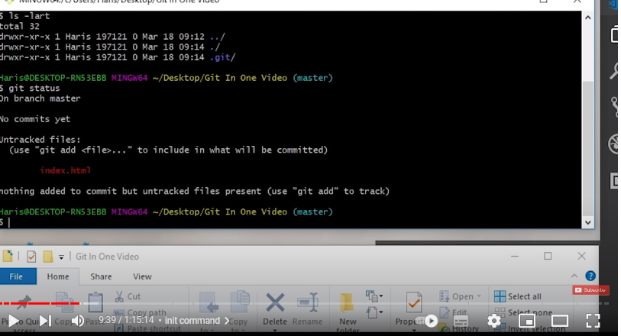

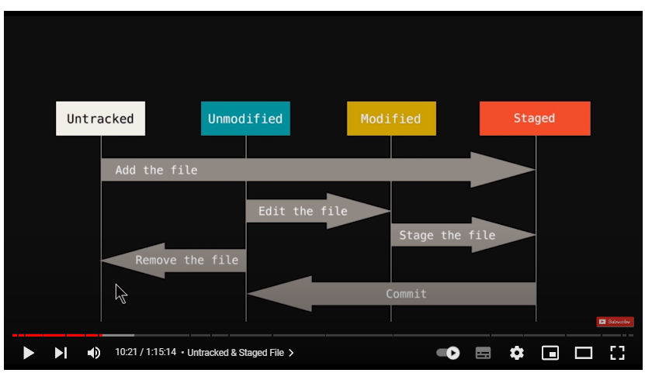

untracked means git ki help se track nahi ki jati like hum file me changes karte hai then commit karte hai jaise humne 3 html file par kam kia index.html1, index.html2 and index.html3 toh hum chate hai ki sirf 1,2 wale ke changes hi commit ho 3 ke nahi to wum stage me dal kar commit karte hai.

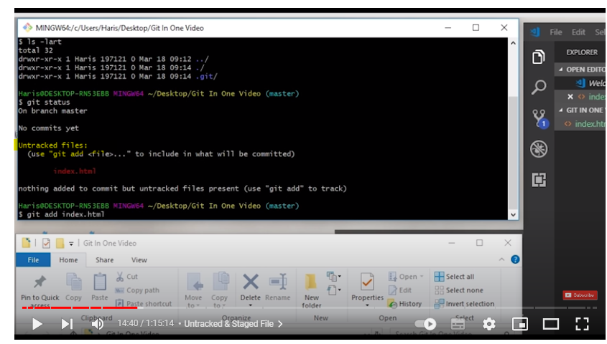

highlighte wala yeh bol raha hai ki hmne track nahi kia haifile kotoh file ko track karne aur staging me le jane ke liye hum “$ git add index.html” command use karenge. then hum check karenge staging me gayi kin ahi toh status check karenge

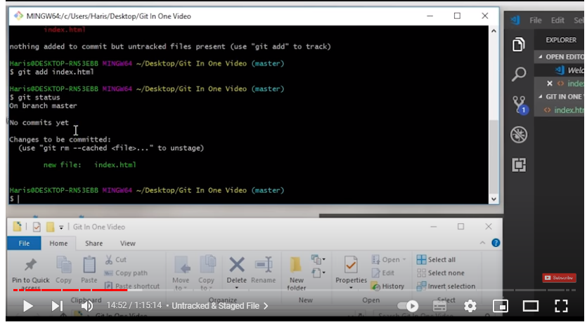

yeh bata raha ki hmari file staging area me chali gayi hai aur yeh bol raha hai ki ab ap isse commit kar lo.

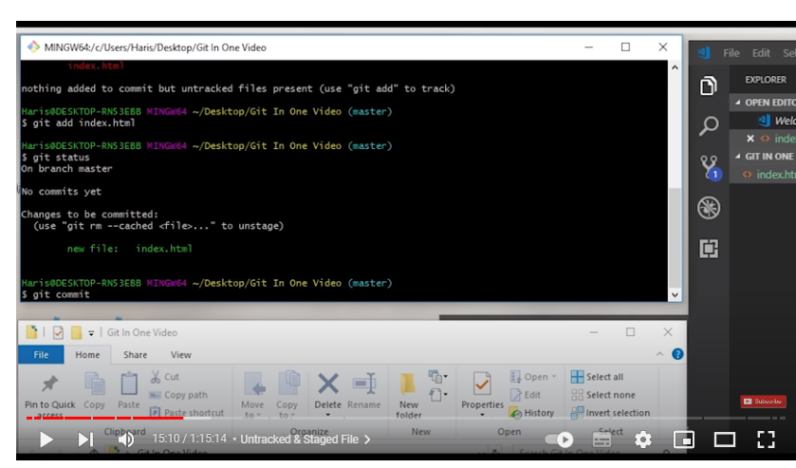 for commit we use “$ git commit” jaise hi hm git commit karte hai toh ek window open hoti hai jisme yeh hota hai ki comment add karo uss file ke liye

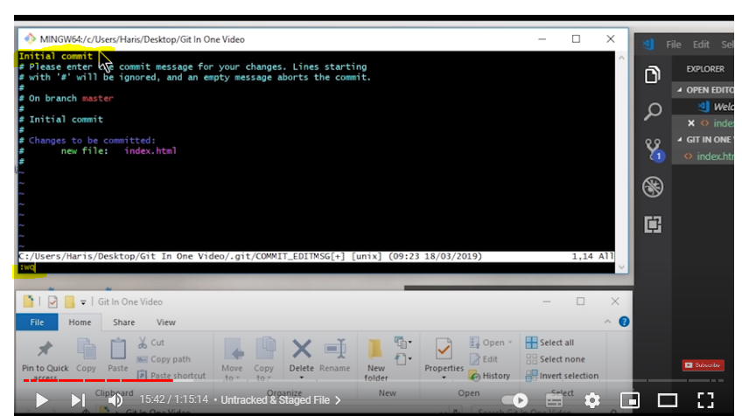

yeh initial commit ( humne iss text ko hi comment bana diya) karne ke bad isse bahar nilne ke liye hum escape press karenge and then neeche “:WQ” type karenge

1. now we create blank file so for that we use”$ touch <blank file name>” eg: $ touch about.html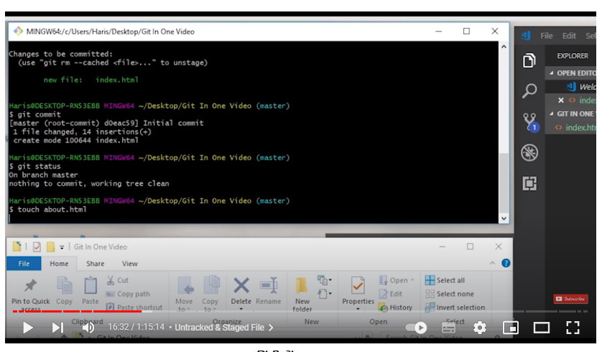
2. now yeh highlighted part bata raha hai ki yeh file track hi nahi ho rahi hai toh sari file ko ek stah track karne ke liye hum”& git add –A” command use karte hai(agar hmare pass 1 lakh se jada file ho toh un sbko ek sath track karne ke liye yeh commend use karte hai.

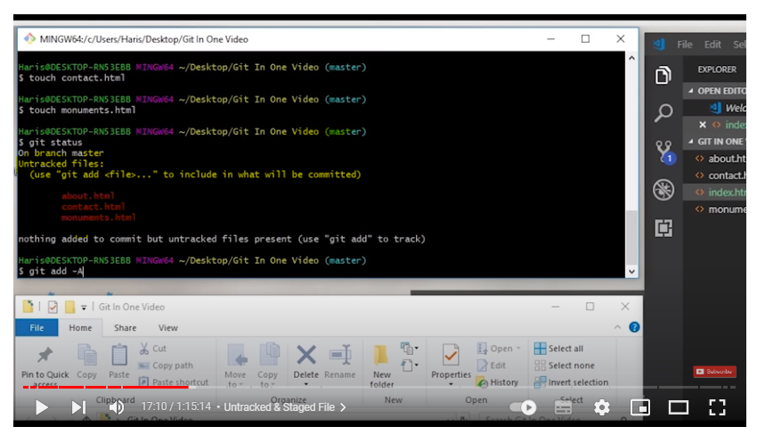

1. ab hme ek file me changes karna hai toh vs studio me changes karke jab fir segit status check karenge toh hum eek file modified dikahegi toh phir se hum isse staging me bhejenge.

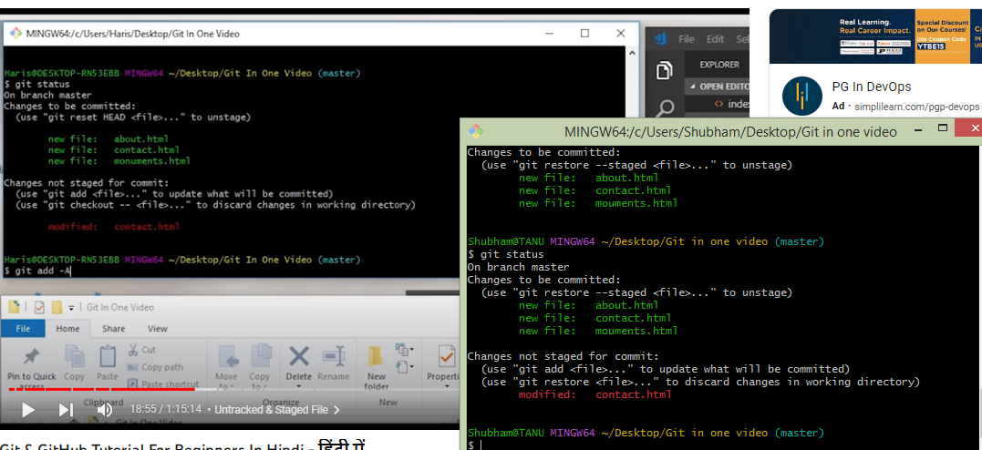

1. phir staging me bhejne ke bad jab hum commit karenge toh hum comment ko sth me aad karenge uske liye hum “$git commit -m “this is my file””

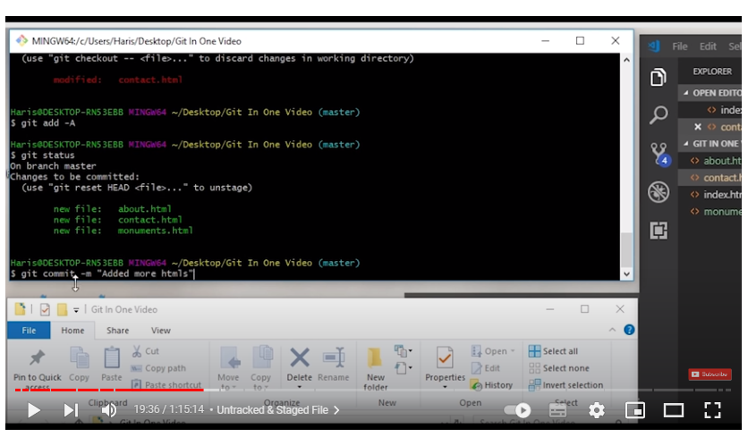

1. agar koi galti se hmari file me kuch change kar deta haito purine wale code ko wapas lane ke liye hum ‘$ git checkout <file name>’ karke purani file wapas la sakte hai

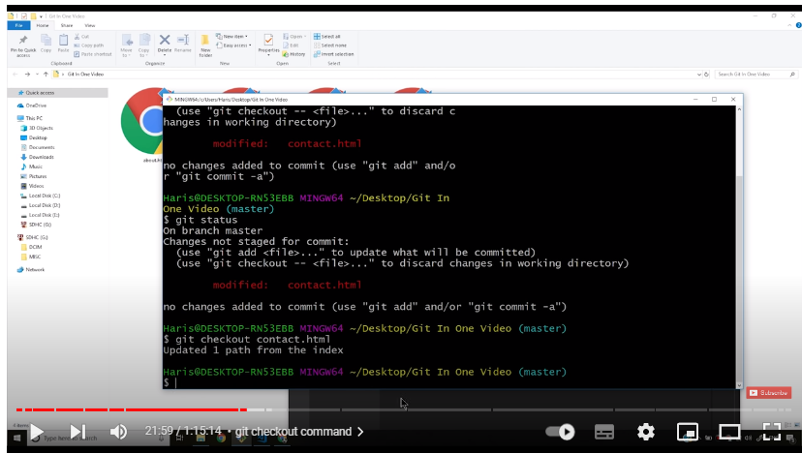

1. agar koi meri sari file me change kar deta hai toh eke k file checkout karne ki jagah hum ek sath sari file checkout kar denge ‘$git checkout –f’ use karenge

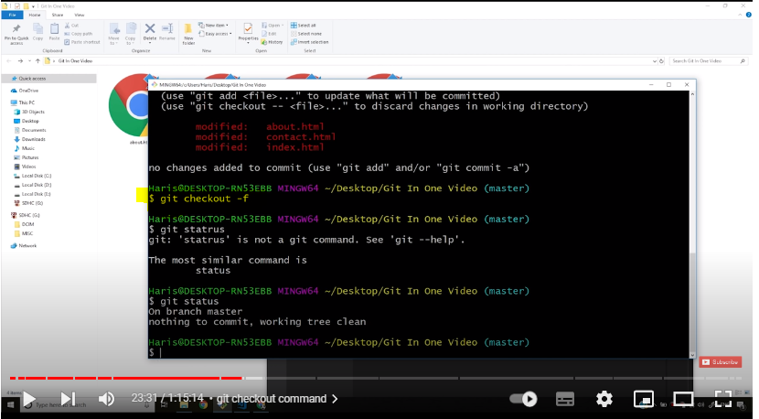

1. ab hum git log command use karenge yeh pata karne ke liye ki humne kya kya use kiya hai .agar hume git log ke output ko filter karna mano humare pass 100 file hai toh hume sirf 5 ka log dekhna hai toh hum ‘$ git log –p -1’ agar 1 dekhna chate hai toh -1 likhenge . aur isse bahar niklne ke liye q press kar denge.

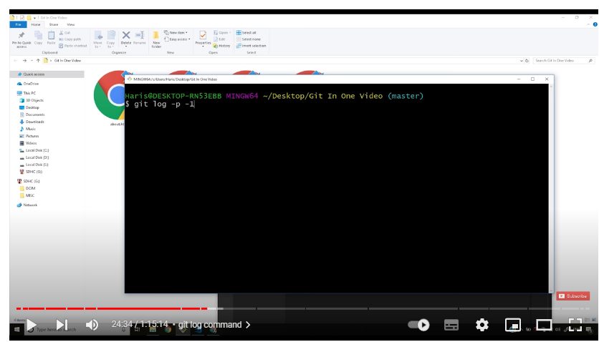

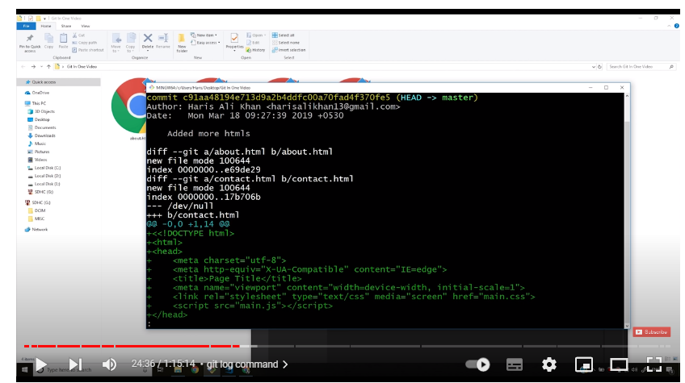

1. now agar hum index.html file me kuch bhi change karte hai toh difference dekhne ke liye hum diff use karte hai like humne <body Shrestha> kar diye apni html file me toh ab hum ‘$ git diff’ karke check kar skte hai ki phle file me kyat ha aur ab kya hai ( diff command working tree ko staging area se match karta hai )

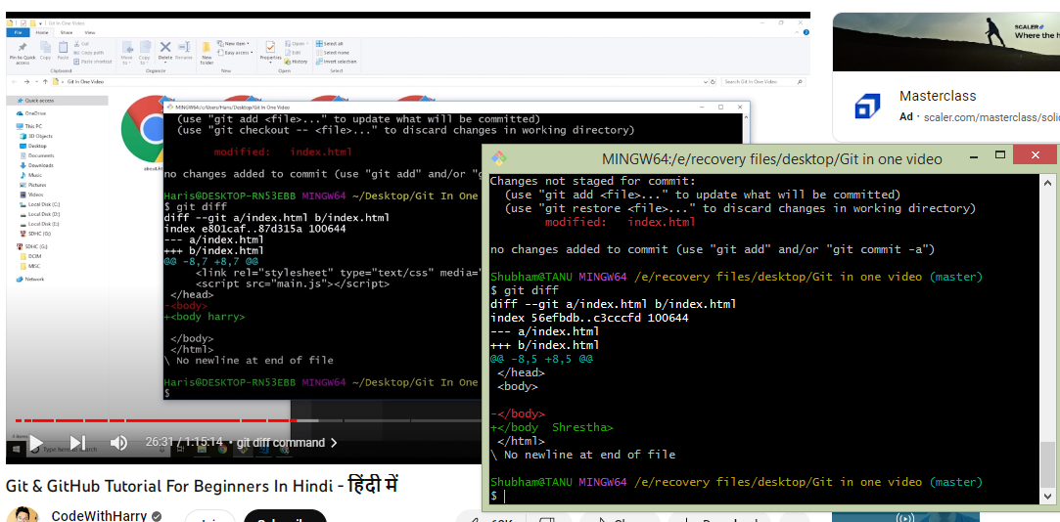

1. agar hm 3 file use kar rahe hai aur hum chahte hai sari file ko ek sath staging area se commit karne toh hum ‘$ git commit –a –m’ use karte with cooment ke sath .

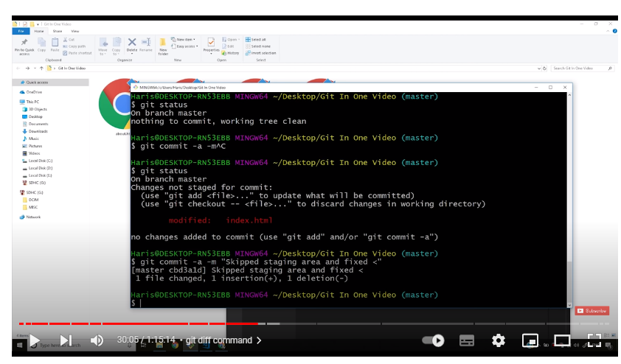

1. agar hume sari file dekhni hai toh “$ls” karte hai ab hume agar koi file remove karni hai toh hum

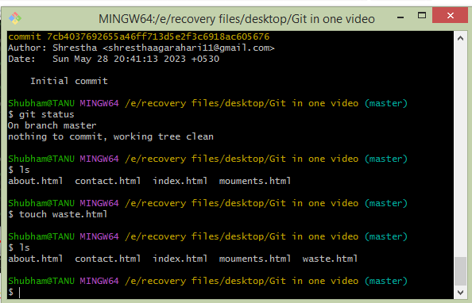

ab phle track karke then commit kia

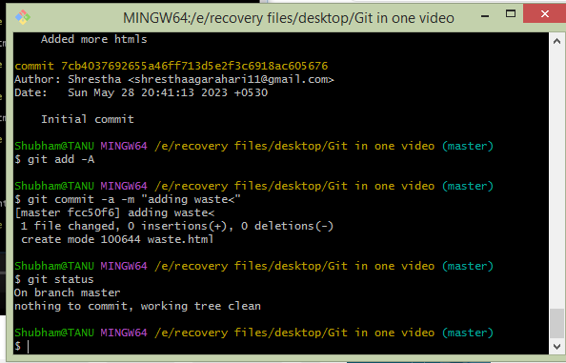

1. ab hume file remove karni hai toh uske liye hu rm use karte hair m kya karta hai yeh remove karta hai working directory se aur staging area se. ab hume kya karna hai hume sirf staging area se remove karna hai toh hum “$ git rm –chached <file name>” command use karte hai

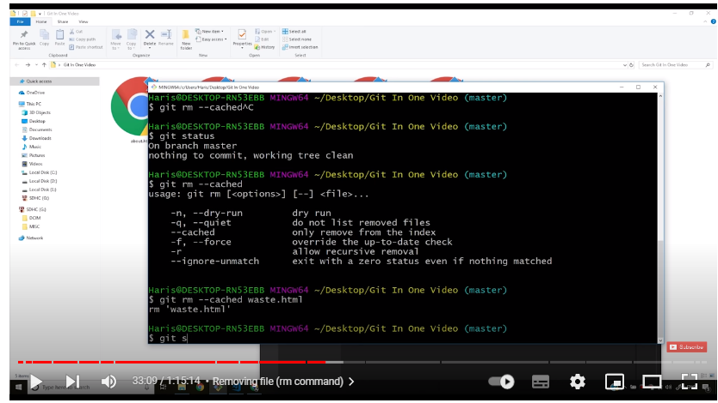

agar hum sirf “$git rm <file name> chalate hai toh file remove ho jayegi. git rm chalne se phle hum isse track staging area me delgenge them remove karenge.

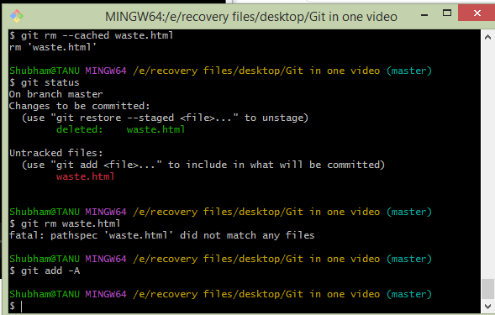

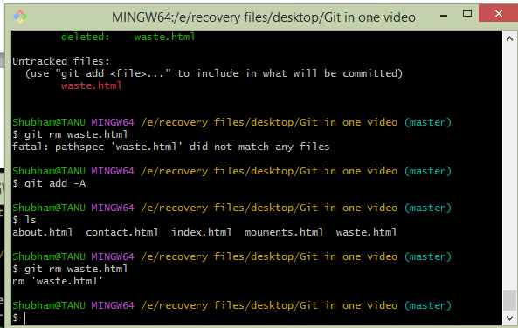

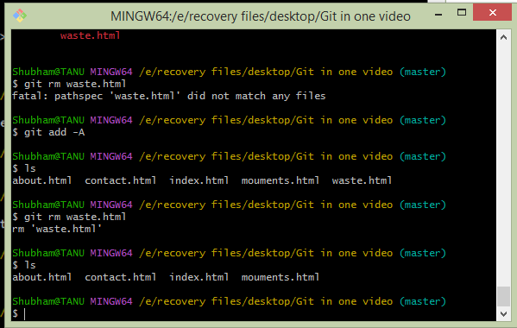

1. ab hum branch ke bare me jante hai bracnch se kya hota haihum alag uss code ki ek copy bana lete hai aur uss copy me changes karte hai ya modifiy karke new features add karte hai then use approve kara kar master branch se merge kar dete hai. master by default main branch hot hai . agar hum git branch me feature add karna chate hai

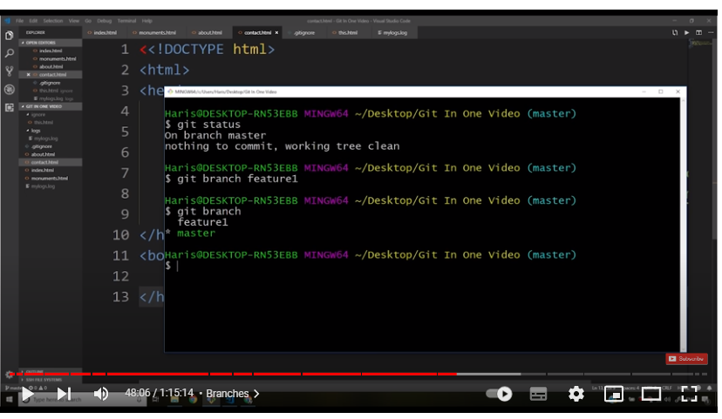

yeh dikha raha hai ki ap abhi master branch me hai but ap feature branch mebhi ja skte hai ab hume feature branch me switch karna hai toh git checkout feature1 karenge

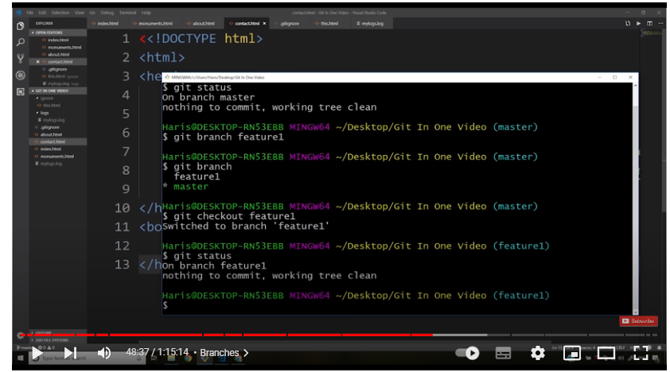

ab hum merge karna chate hai feature ko mater file ke andar toh hum git merge feature1 karenge.

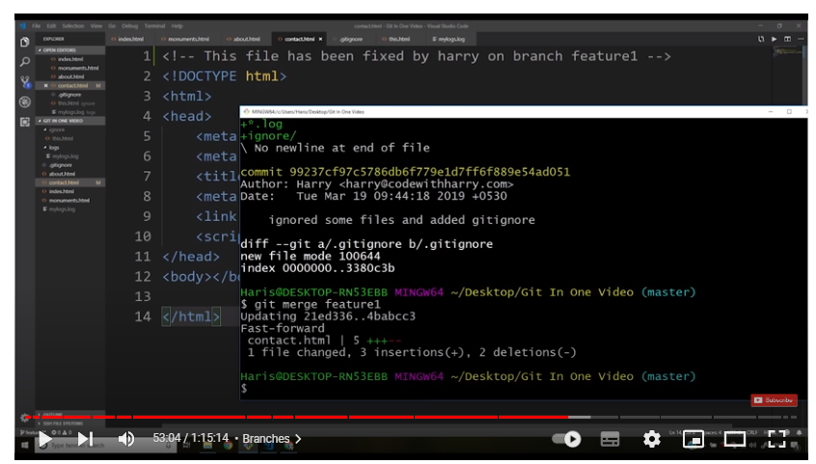

1. ab hum apna code git hub me push karenge uske liye phle hum git hub me jakar new repository bnayenge jo ki ek remote repository hogi ab hum remote repo ke andar hmari local repo(jo gt bash me kia hai) ko push karenge

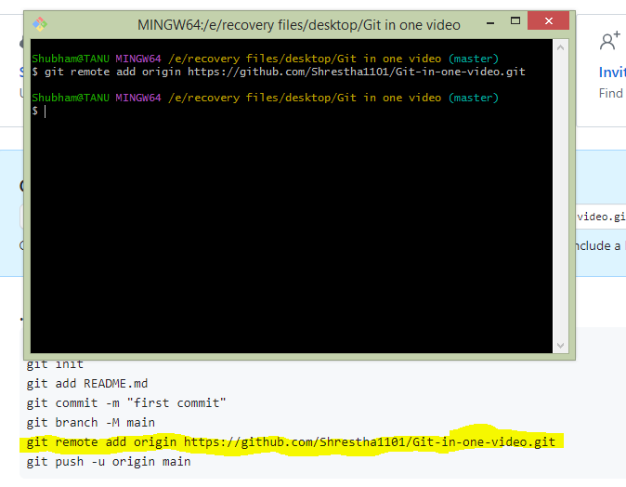

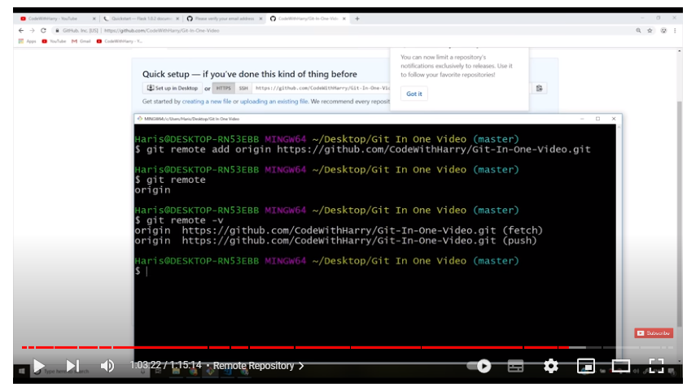

git remote –v hume 2 URL dega jo batayega hume fetch kaha se karna hai aur push kaha karna hai

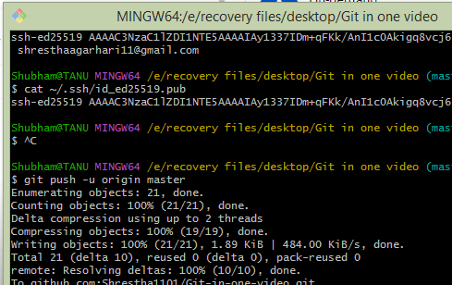

then we push code.